**Завдання 1**

**CREATE user**

**Request Body (JSON):**

*name* (required) - string, min 6, max 20 symbols

*age* (required) - number, min 1 max 100

*gender* (required) - string: only “male” or “female”

*city* (optional) - string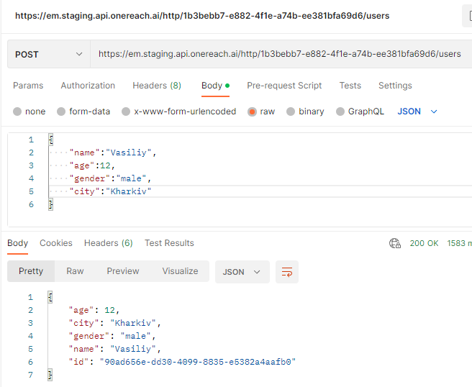

**GET User**

**Request Body:** none

**Request params:** id - string

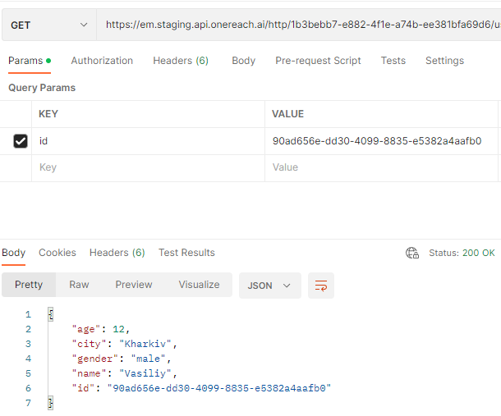

**EDIT user**

**Request Body (JSON):**

*id (required) - string*

*name* (required) - string, min 6, max 20 symbols

*age* (required) - number, min 1 max 100

*gender* (required) - string: only “male” or “female”

*city* (optional) - string

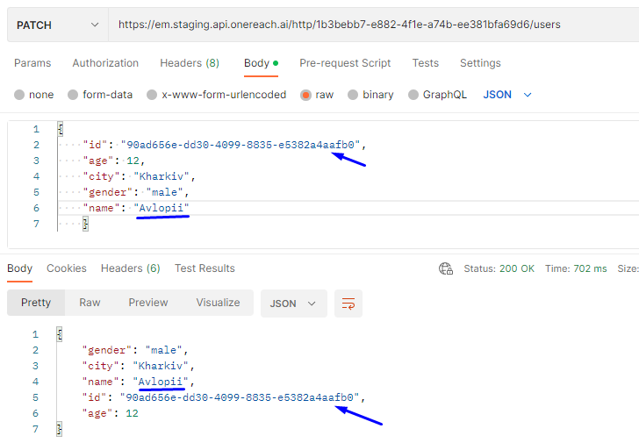

**DELETE user**

**Request Body:** none

**Request params:** id - string

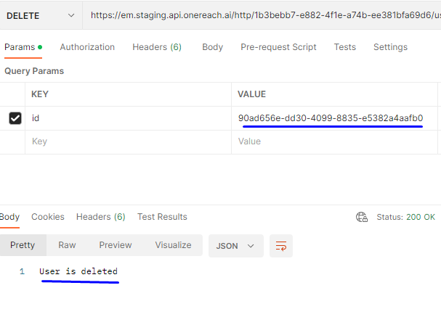

**Завдання 2 і 3**

https://crimson-astronaut-707249.postman.co/workspace/My-Workspace~bd332e4b-8801-41cb-8874-cbac4cde28c4/collection/24250652-f6e5b16b-1e19-4b11-83b7-7df761df5149?action=share&creator=24250652

